**Worksheet Part I: Build a Secure and Efficient Linux Infrastructure**

IMPORTANT: Please complete the Lab Safety Acknowledgement for AY24 Semester 1 via this URL: [**https://forms.office.com/r/spScG2CKU9**](https://forms.office.com/r/spScG2CKU9)

|  |
| --- |
| **Academic Week 1 - Block I** |

**LEARNING OBJECTIVES**

* Describe the features of a Linux system.

|  |
| --- |
| **Accessing Lab Resources** |

* Your facilitator will guide and demonstrate on the below
  + To access Red Hat Academy learning resources and labs for individual submissions.
  + To copy the OVF from the thumb drive and to install RHEL on your local computer.
* You need to use local VM to practice Linux commands and to complete “Do It Yourself” lab questions in the worksheet.
* You need to use local VM during practical quiz and ESE to test Linux commands.
* If you have difficulties to install RHEL on local VM approach your facilitator.

For Team Activities:

* + Each team will be assigned a virtual machine
  + Team members need to work collaboratively to solve the problem statement using this virtual machine.

|  |
| --- |
| **Problem Definition Template (PDT)** |

* Discuss among your team and start working on the PDT to break down the problem statement. Use the given template C330 _PDT_Template.docx.
* Upload the PDT into the MS Teams private channel which you are assigned to. Do use the MS Teams channel to collaborate with each other & work on the PDT internally.
* Your input and contribution will be used as part of the assessment for collaborative learning portion of your CA assessment.
* Each team will be assigned a VM. Use the VM to build your solution for the problem statement and you need to demonstrate the completion of tasks during week 6.

|  |
| --- |
| **Prior Knowledge** |

|  |
| --- |
| **Do It Yourself!** |

1. Based on your prior knowledge from **C226**, discuss within your team and answer the following questions
2. What is Virtualisation?
3. Explain the role of hypervisor. Give examples of hypervisor.
4. Do you have experience in using VMware Workstation to run multiple operating systems on multiple virtual machines on your laptop? What are the advantages of Virtualisation?

|  |
| --- |
| * 1. The act of creating virtual version of something at the same abstraction level.   2. A form of virtualization software used in Cloud hosting to divide and allocate the resources on various pieces of hardware. It provides partitioning, isolation, or abstraction. This technique allows multiple gues OS to run on a single host system.   3. Yes. Virtualization allows IT users to use their hardware to their full capabilities, resulting to little to no waste of computing resources. |

|  |
| --- |
| **RH124 Chapter 1: Getting Started with Red Hat Enterprise Linux** |

|  |
| --- |
| **Lecturer Presentation** |

* Students to follow lecturer presentation and demonstration and clarify doubts
* Participate in team and class discussions

|  |
| --- |
| **Do It Yourself!** |

1. What is an open source software? What are the advantages of using open source software as compared with proprietary software and what are the challenges faced in adopting open source software?

|  |
| --- |
| Open Source software is software with source code that anyone can use, study, modify, and share.  Open-source software means that improvements are easier to make, which enable faster innovation. |

1. Explain the main function of Linux kernel? What do you understand by a Linux distribution? How Red Hat Enterprise Linux (RHEL) is different from other Linux distributions?

(hint: <https://en.wikipedia.org/wiki/List_of_Linux_distributions>)

|  |
| --- |
| Linux kernel is the core of the operating system and manages hardware, memory, and the scheduling of running programs. Linux distribution consists of Linux kernel and support user-space programs. RHEL is an active participant in the Linux community. |

|  |
| --- |
| **RH124 Chapter 2: Accessing a Linux System and RH124 Chapter 4: Getting Help in Linux** |

|  |
| --- |
| **Lecturer Presentation and Demonstration** |

* Students pay attention to lecturer presentation and demonstration
* Participate in team and class discussions
* Clarify doubts

|  |
| --- |
| **Do It Yourself!** |

1. Explore the features of a Linux system such as navigating around the desktop and running simple. Include screenshots from lab guide.

|  |
| --- |
|  |

1. What are the different ways to get help in a Linux system? Include a screenshot to show them. (Hint: man, info, --help, whatis)

|  |
| --- |
|  |

1. What are the different ways to access the command line?

|  |
| --- |
| * + - Clicking on the terminal on the desktop.     - Clicking on the terminal tab. |

1. Refer to the screenshot below to answer the following questions.

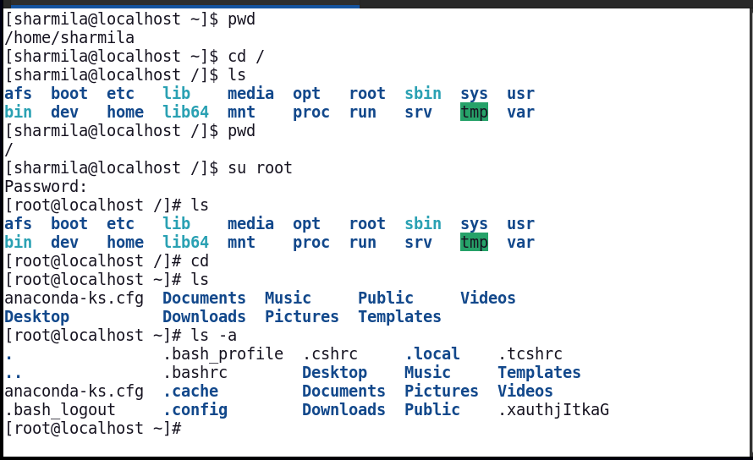

1. Notice that there are two different prompts namely **$** and **#**. What is the difference between them?
2. What is the command to switch between users?
3. To list the contents of a directory, **ls** command is used. Try different options in **ls** command such as **-a**, **-l**, etc., Include a screenshot and how do they differ from each other?

|  |
| --- |
| * 1. ‘$’ means the user is logged in as a standard user. ‘#’ means the user I logged in as superuser, which has full control over the system and can perform any action.   2. ‘su’ |

|  |
| --- |
| **Academic Week 1 - Block II** |

**LEARNING OBJECTIVES**

* Explain the Linux File-system hierarchy to organize files and directories.

|  |
| --- |
| **RH124 Chapter 3: Managing Files From the Command Line** |

|  |
| --- |
| **Lecturer Presentation and Demonstration** |

* Students pay attention to lecturer presentation and demonstration
* Participate in team and class discussions
* Clarify doubts

|  |
| --- |
| **Lab Activity** |

1. Complete the guided exercise RH124: Chapter3: Guided Exercise: Manage Files Using Command-line Tools

(Hint: Refer to the RHALP Lab Guide to access Red Hat labs host on the cloud. You are given only 60hrs. So, shutdown the VMs once you have completed to optimize the lab usage)

|  |
| --- |
|  |

|  |
| --- |
| **Do It Yourself! Skills Relevant to Practical** |

1. You are currently in **/home/student**. Using absolute path, switch to **/etc** directory. What is the absolute path to navigate to the **/var/log** from **/etc** directory. Include the commands and screenshot of your answers.

|  |
| --- |
|  |

1. You are currently in **/home/student**. What is the relative path to navigate to **/etc** directory? Include the commands and screenshot of your answers.

|  |
| --- |
|  |

1. Create a new directory **<yourname_test>** in your home folder. In **<yourname_test>**, create another directory **<yourclass_test>.** (Hint: use man command to explore **mkdir** options to create the two directories in a single command).

|  |
| --- |
|  |

1. From your home directory, what is the command to remove the two directories created in the above question? (Hint: Use **man** command to see more options)

|  |
| --- |
|  |

1. Observe screenshot below to answer the following questions

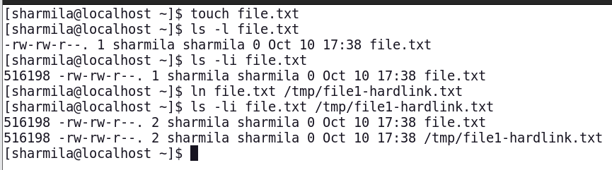

* 1. How many files are created?
  2. What is an inode number and how can you list the files with inode number?
  3. What are the limitations of hard links?

|  |
| --- |
| * 1. 2 files   2. ls -li file.txt   3. Hard-links can only be created within the same file system. |

1. Complete the following tasks
   1. Create a file **one.txt** and include a line “original contents”.
   2. Create a soft link named **/home/student/sl_one.txt** that points to the **one.txt** and append a line “testing soft link” to the file **/home/student/sl_one.txt**
   3. Verify the newly created soft link and its contents.
   4. Now delete the file **one.txt**. Verify the newly created soft link and its contents. What do you observe?

|  |
| --- |
| It points to nothing. |

1. Do a list of all the files in the **/var/log/** directory which have more than a 3-letter extension after the first “***.***” (dot) in their filenames. E.g. test.log file does not match but test.log.log does.

|  |
| --- |
|  |

1. How many directories will be created after executing the below command?



|  |
| --- |
| 4 directories.   * + - * + edible         + fruits_apple         + fruits_organe         + fruits_banana |

|  |
| --- |
| **Submissions for LPP1 Academic Week 1**  **No submissions** |

|  |
| --- |
| **LPP1 Academic Week 2 – E-Learning** |

**LEARNING OBJECTIVES**

* Perform file operations such as create, view, edit and delete files using Command Line Interface (CLI) or text editor.
* Differentiate the types of users and types of groups.
* Create, modify, and delete users and groups using CLI.

|  |
| --- |
| **Follow the instructions for E-Learning to complete your deliverables** |

* Lesson 2 (from **22nd to 26th Apr),** will be conducted using Asynchronous E-Learning mode.
* You will **NOT** be required to come to RP campus on the day of your Lesson day.
* Submit your deliverables to individual submissions folder in LEO 2.0 by 28th Apr 23:59.

|  |
| --- |
| **RH124 Chapter 5: Create, View and Edit Text Files**  **RH124 Chapter 6: Manage Local Users and Groups** |

Read **RH124 Chapter 5: Create, View and Edit Text Files** to complete quizzes and guided exercises. Refer to the below screenshot for the topics to be completed for week 2.

Read **RH124 Chapter 6: Managing Local Users and Groups** to complete quizzes and guided exercises. Refer to the below screenshot for the topics to be completed for week 2.

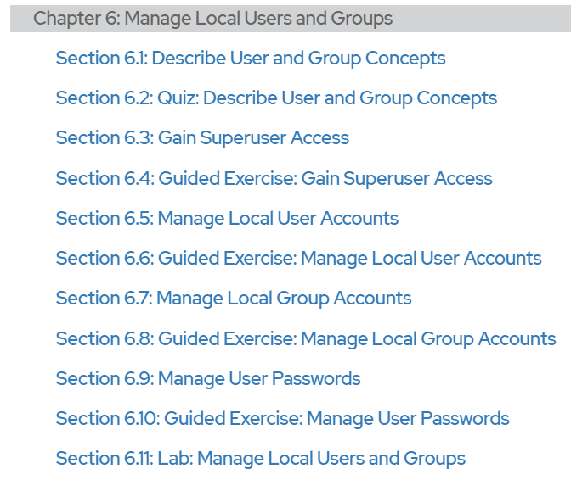

|  |
| --- |
| **Submissions for Academic Week 2 by 23:59 Sunday 28th Apr**  Complete the following labs.   * + - * + RH124 Chapter 5: Section 5.7: Lab: Create, View and Edit Text Files         + RH124 Comprehensive Lab: Chapter 15: Section 15.2 Manage Files from the Command Line         + Once you have completed, capture the screenshot of your lab completion together with your Red Hat login ID in a word document. Upload to individual submission folder in Leo 2.0 by 23:59 Sunday 28 April.         + Refer to the sample screen shot for Chapter 15 lab. Make sure that all tasks are completed in the lab and the lab grade should be “PASS”. |

|  |
| --- |
| **Academic Week 3 - Block I** |

|  |
| --- |
| **Revisit E-Learning concepts** |

* Kahoot Quiz on week 2 concepts

|  |
| --- |
| **Lecturer Presentation on week 2 E-Learning topics (C330 Lesson 2 slides.pptx)** |

* Students pay attention to lecturer presentation and demonstration.
* Participate in team and class discussions.
* Clarify doubts.

**LEARNING OBJECTIVES**

* Set up file-system permissions on files and folders using CLI.

|  |
| --- |
| **Lecturer Presentation and Demonstration (C330 Lesson 3 Slides.pptx)** |

* Students pay attention to lecturer presentation and demonstration.
* Participate in team and class discussions.
* Clarify doubts.

|  |
| --- |
| **Lab Activity** |

1. Complete the lab exercise RH124: Chapter 7: Section 7.7: Control Access to Files and include a screenshot of your completed work. If you have any questions, clarify with your lecturer.

|  |
| --- |
|  |

|  |
| --- |
| **Academic Week 3 - Block II** |

**LEARNING OBJECTIVES**

* Set up file-system permissions on files and folders using CLI.
* Demonstrate the tasks of managing users to groups, and the setting of files and folders permissions using CLI, for a given scenario.

|  |
| --- |
| **Lab Activity (30 mins)** |

1. Complete the lab exercise RH124: Chapter 15: Section 15.3: Lab: Manage Users and Groups, Permissions and Processes.   
   This lab activity is included as part of your SDL submission and include a screenshot of your completed work. If you have any questions, clarify with your lecturer.

|  |
| --- |
|  |

|  |
| --- |
| **Team Activity (30 mins)** |

This activity will help to set up the users/groups and control access to files and directories for the problem statement applying the knowledge and skills covered from week1 to week 3.

1. You are given 30 mins to complete the activity. Work in teams to identify the number of users/groups, files and directories and control access.
   * Revisit the problem statement.
   * Identify the number of users/groups, files/directories, password setting policies.
   * How to work collaboratively between departments by sharing files and directories?
   * How to have certain files and directories confidential for each department?
   * Use local VM, implement the steps using command line interface (CLI)
   * Students are randomly selected to demonstrate the tasks.

|  |
| --- |
| Users (Employees): 12  Groups (Departments): 6  Directories: joint_project  Files: documents, resources, backup, etc.  How to work collaboratively between departments by sharing files and directories?   * + - * + Soft-linking relevant directories         + The reason to use this instead of hard-linking method is because we want to ensure the directories’ integrity is not compromised by creating shortcut.   How to have certain files and directories confidential for each department?   * + - * + Assigning users to groups they are supposed to be in.         + For example, only the HR department (group) are allowed to access HR resources. |

|  |
| --- |
| **Submissions for LPP1 Academic Week 1**  **No submissions** |

|  |
| --- |
| **Academic Week 4 - Block I** |

**LEARNING OBJECTIVES**

* Write bash scripts to automate Users and Groups management tasks to access files and directories using loops for a given scenario

|  |
| --- |
| **RH134 Chapter 1: Improve Command-line Productivity** |

|  |
| --- |
| **Lecturer Presentation and Demonstration** |

* Students pay attention to lecturer presentation and demonstration
* Participate in team and class discussions
* Clarify doubts

|  |
| --- |
| **Guided Exercise and Lab Activity** |

1. Complete the guided exercise RH134: Chapter 1: Section 1.2: Guided Exercise: Write Simple Bash Scripts and include a screenshot of your completed work.

|  |
| --- |
|  |

1. Complete the guided exercise RH134: Chapter 1: Section 1.4: Guided Exercise: Loops and Conditional Constructs in Scripts and include a screenshot of your completed work.

|  |
| --- |
|  |

|  |
| --- |
| **Do It Yourself!** |

1. Below is an example of a shell script. Open vim clear editor and type the lines as per the below screenshot. Save in a file **first.sh** and change the permission to executable by typing the command **chomd +x first.sh** and type **./first.sh** to execute it. What is the output of **first.sh**?

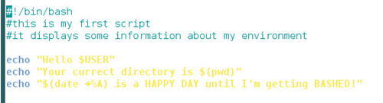

|  |
| --- |
|  |

1. Observe the below program and explain how do we input the values of positional parameters? How many positional parameters are there? What is the output of the shell script, if we execute as **./pp.sh one two three**?

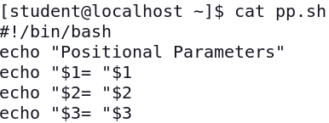

|  |
| --- |
| To input the values, you separate them by spaces after typing in the script name.  3 positional parameters. |

1. Try the below and observe the output. What does a **$** used for in the below output?

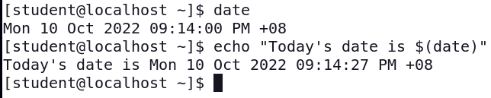

|  |
| --- |
| To display the output of the command within the string. |

1. Try the below in your command line. What is the output and what is the purpose of using **seq**?

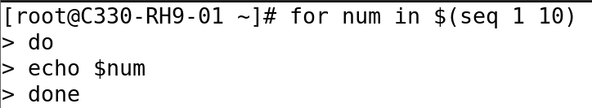

|  |
| --- |
| To create a list of numbers from 1 to 10. |

1. Using for loop, write a script **list.sh** that lists all files in the current directory. Run the script and include the script and the output of **list.sh**

(Note: You are rewriting the ls command without using it)

|  |
| --- |
|  |

1. What will be the below script do? Execute the below script by inputting different arguments and observe the output. What is the purpose of **$#** and **$@** in the script?

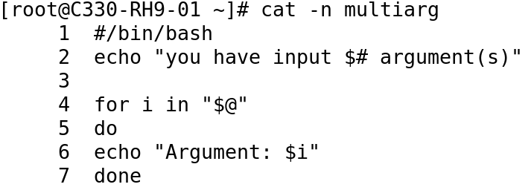

|  |
| --- |
| “$#” is the number of arguments inputted.  “$@” is the list of arguments inputted. |

|  |
| --- |
| **Academic Week 4 - Block II** |

**LEARNING OBJECTIVES**

* Write bash scripts to automate Users and Groups management tasks to access files and directories using loops for a given scenario.

|  |
| --- |
| **RH134 Chapter 1: Improve Command-line Productivity** |

|  |
| --- |
| **Lecturer Presentation and Demonstration** |

* Students pay attention to lecturer presentation and demonstration.
* Participate in team and class discussions.
* Clarify doubts.

|  |
| --- |
| **Guided Exercise and Lab Activity** |

1. Complete the guided exercise RH134: Chapter 1: Section 1.6: Match Text in Command Output with Regular Expressions and include a screenshot of your completed work.

|  |
| --- |
|  |

1. Complete the lab RH134: Chapter 1: Section 1.7: Lab Improve Command-line Productivity and include a screenshot of your completed work.

|  |
| --- |
|  |

|  |
| --- |
| **Team Activity (continued)** |

This activity will help to automate the users/groups creation, implement password policies and control access to files and directories for the problem statement.

1. You are given 30 mins to complete the activity. Refer to the team activity completed in week 3 using CLI commands. In this activity you need to automate the tasks by writing a shell script. There will a VM assigned to each team and your lecturer will share the details of username and password.
   * Based on your understanding of writing bash scripts, discuss with your team to automate the tasks for Team Activity.
   * Use individual VM to practice writing a Linux script to automate the tasks in Team Activity for each department. (Hint: use looping)
   * Use the Team VM to write a script using nested looping to implement all tasks in Team Activity.
   * Include relevant information and screenshots (done in local VM/Team VM) to show the completion of each team members’ work and their contribution.

|  |
| --- |
| **Submission for Academic Week 4**  **No submissions** |